Year 9 |  | Surds | Non Calculator
Skills and Knowledge Assessed:  - Define rational and irrational numbers and perform operations with surds and fractional indices (ACMNA264) |  |  | Name_________________
Section 1 Short Answer Section
Write all working and answers in the spaces provided on this test paper.

 | Circle the irrational numbers in the list below.
Simplify : 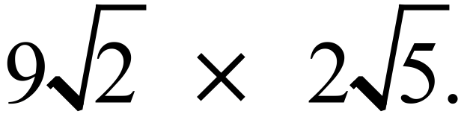

…………………………………………………………………………………………………………
Simplify : 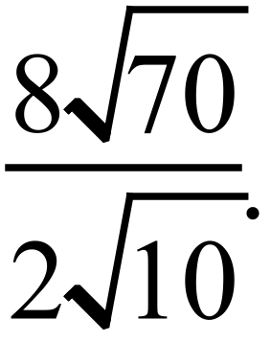

………………………………………………………………………………………………………
Simplify : 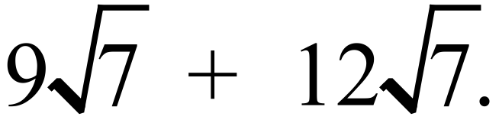

…………………………………………………………………………………………………………
Simplify : 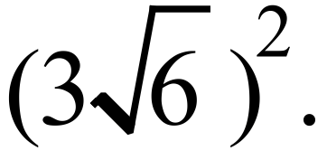

…………………………………………………………………………………………………………
Simplify : 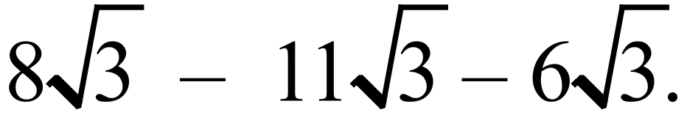

…………………………………………………………………………………………………………
Simplify : 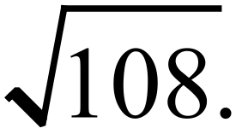

…………………………………………………………………………………………………………
Simplify : 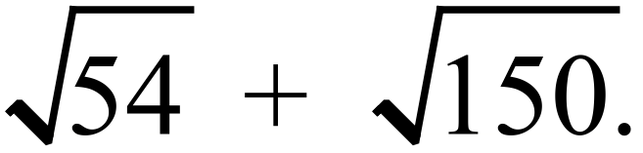

…………………………………………………………………………………………………………
Simplify : 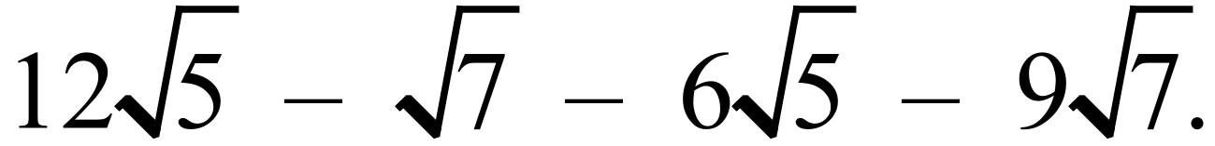

…………………………………………………………………………………………………………
Simplify : 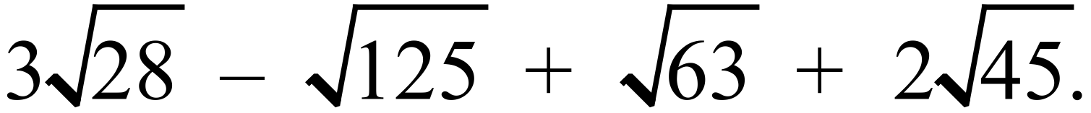

…………………………………………………………………………………………………………

…………………………………………………………………………………………………………
Express with a rational denominator : 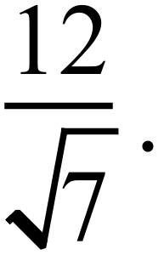

…………………………………………………………………………………………………………
Express in simplest form, with a rational denominator : 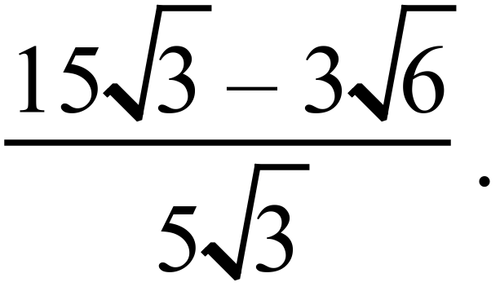

…………………………………………………………………………………………………………

…………………………………………………………………………………………………………
Expand and simplify : 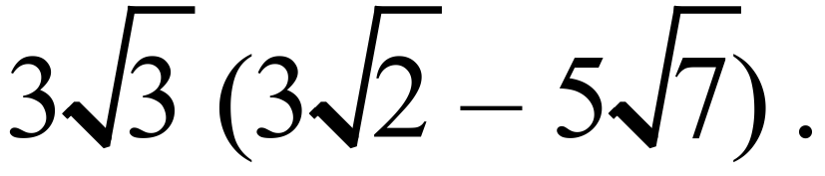

…………………………………………………………………………………………………………
Expand and simplify : 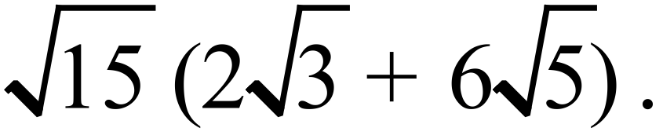

…………………………………………………………………………………………………………

…………………………………………………………………………………………………………
Expand and simplify : 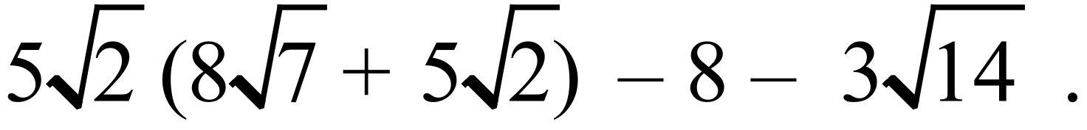

…………………………………………………………………………………………………………

…………………………………………………………………………………………………………
Expand and simplify : 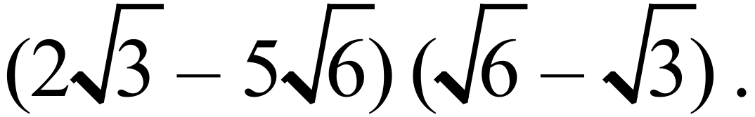

………………………………………………………………………………………………………

…………………………………………………………………………………………………………
If 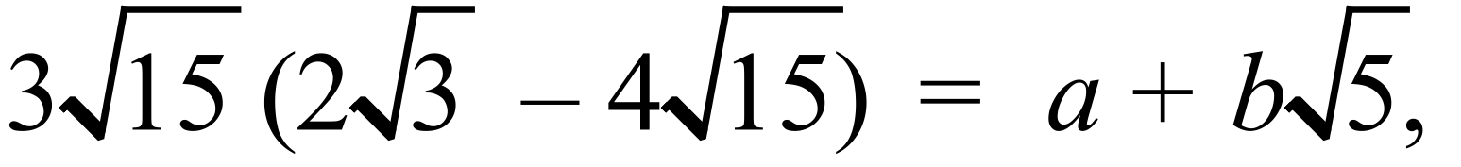 what are the values of a and b?

…………………………………………………………………………………………………………

…………………………………………………………………………………………………………
Arrange the numbers 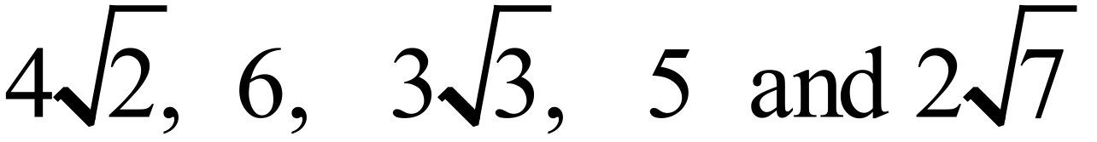in ascending order.

…………………………………………………………………………………………………………

…………………………………………………………………………………………………………

Year 9 |  | Surds | Calculator Allowed
 |  | Surds | Name_________________
Section 2 Multiple Choice Section
Mark all your answers on the accompanying multiple choice answer sheet, not on this test paper. You may do any working out on this test paper. Calculators are allowed for this section.

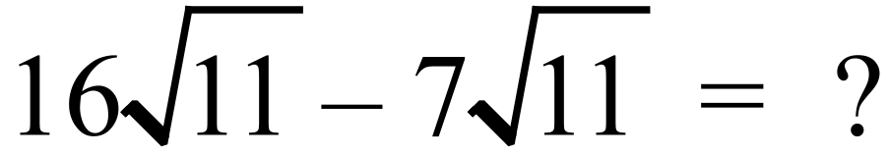

A. 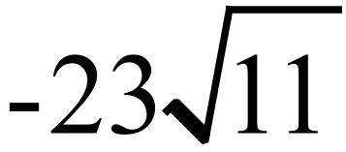 B. 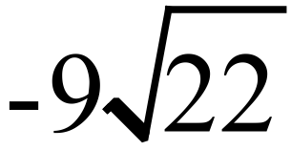 C. 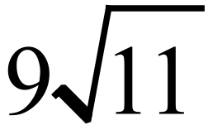 D. 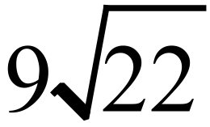
Which of the numbers below is a rational number?

A. 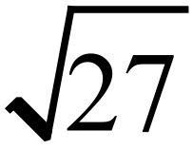 B. 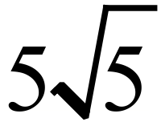 C. 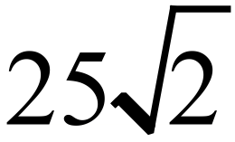 D. 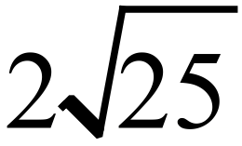
Simplify 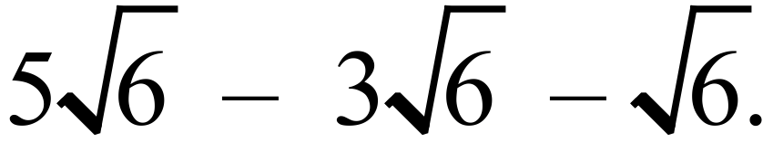

A. 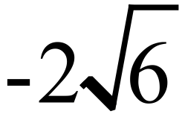 B. 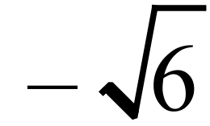 C. 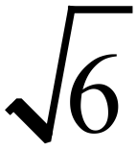 D. 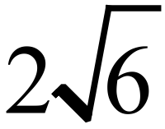
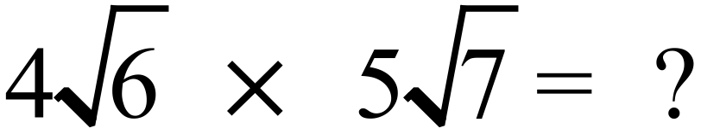

A. 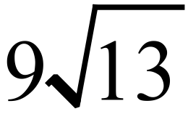 B. 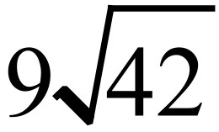 C. 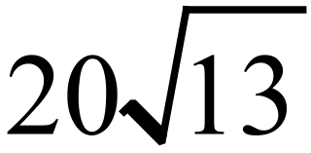 D. 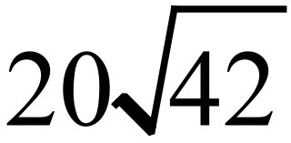
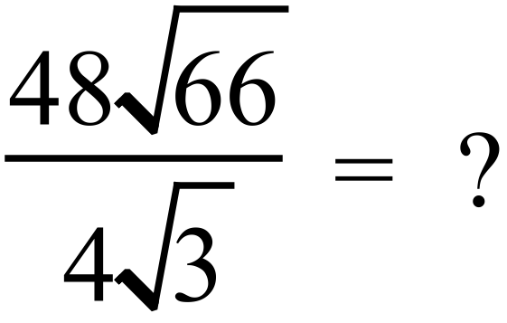

A. 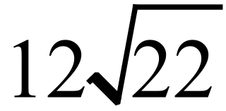 B. 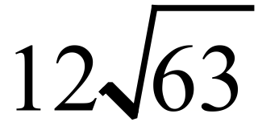 C. 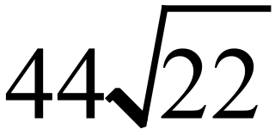 D. 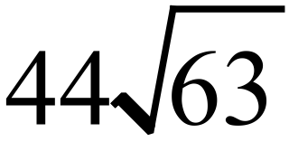
Completely simplify 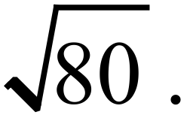

A. 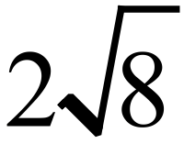 B. 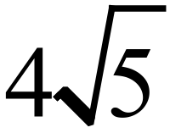 C. 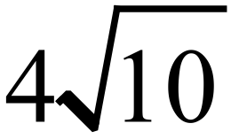 D. 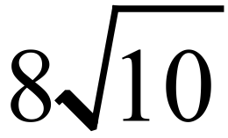
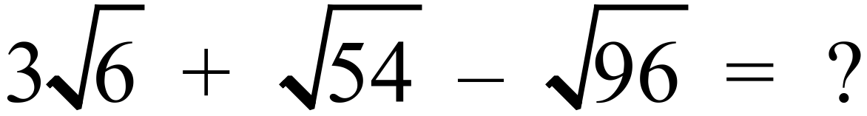

A. 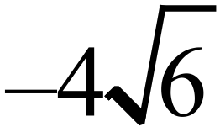 B. C. 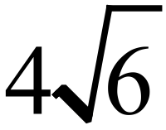 D. 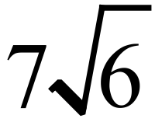
 | A. 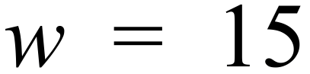 B. 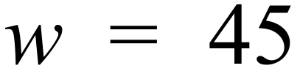 C. 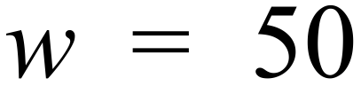 D. 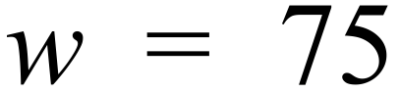
Which of the following has the least value?

A. 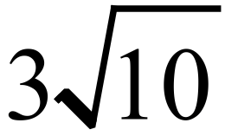 B. 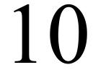 C. D. 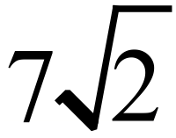


A. 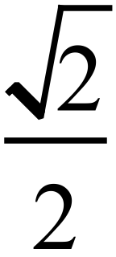 B. 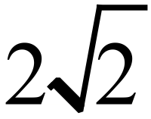 C. 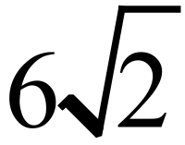 D. 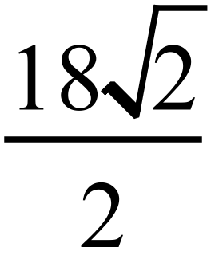
Expand and simplify 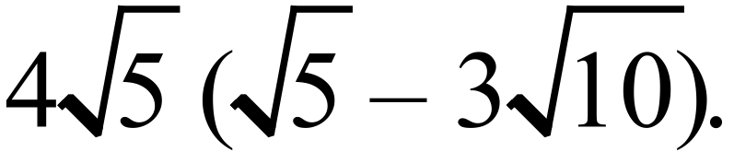

A. 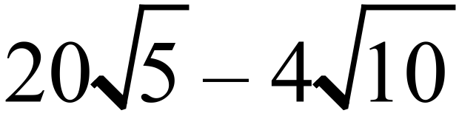 B. 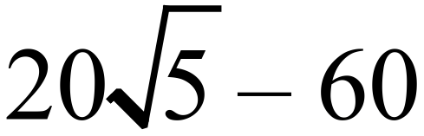

C. 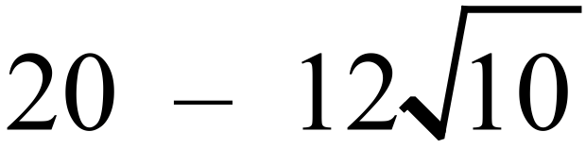 D. 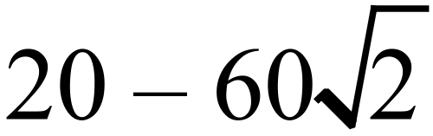
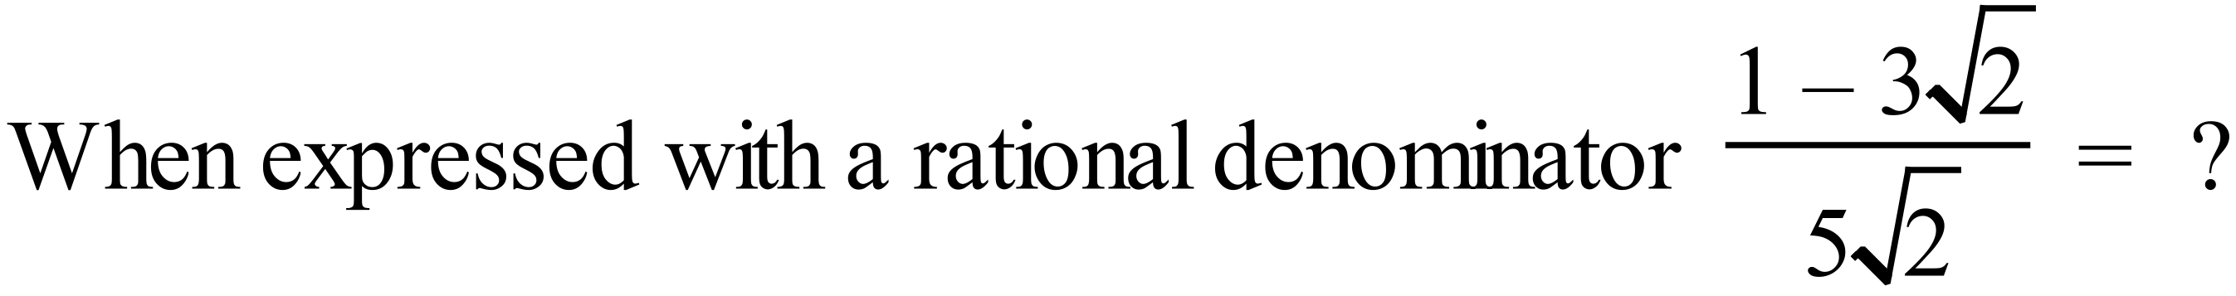

A. 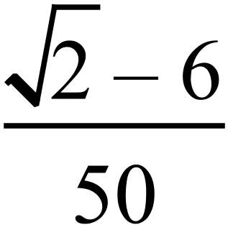 B. 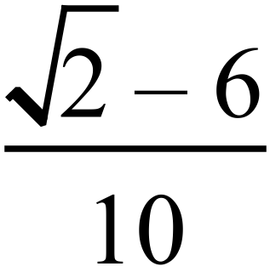 C. 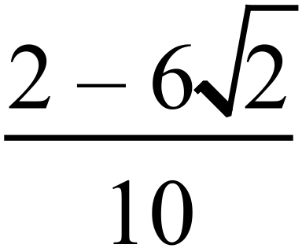 D. 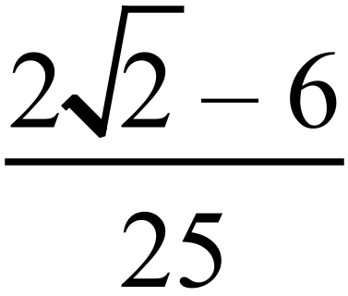
Expand and simplify 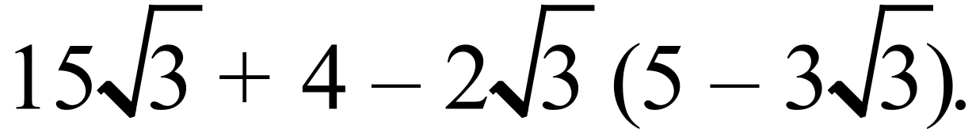

A. 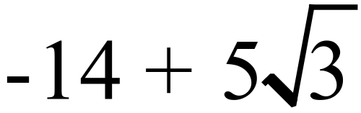 B. 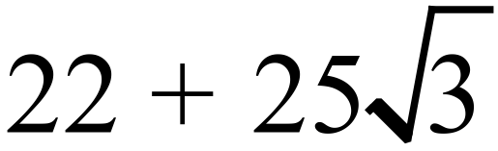

C. 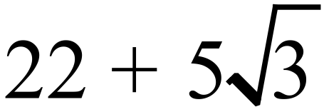 D. 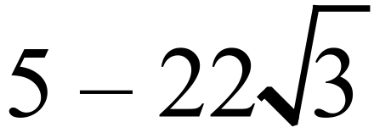

A. 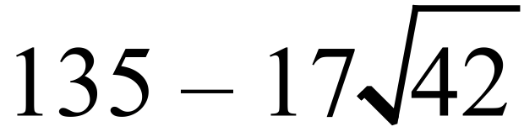 B. 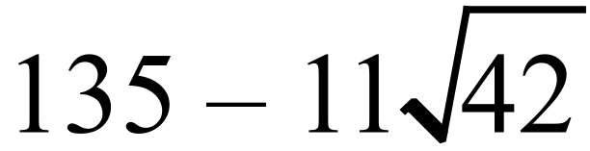

C. 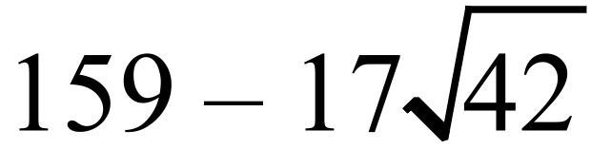 D. 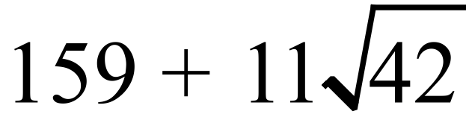
Given that the centre for the arc drawn below is the point O on the number line, and PQ is perpendicular to OP, what number is represented by the point K?
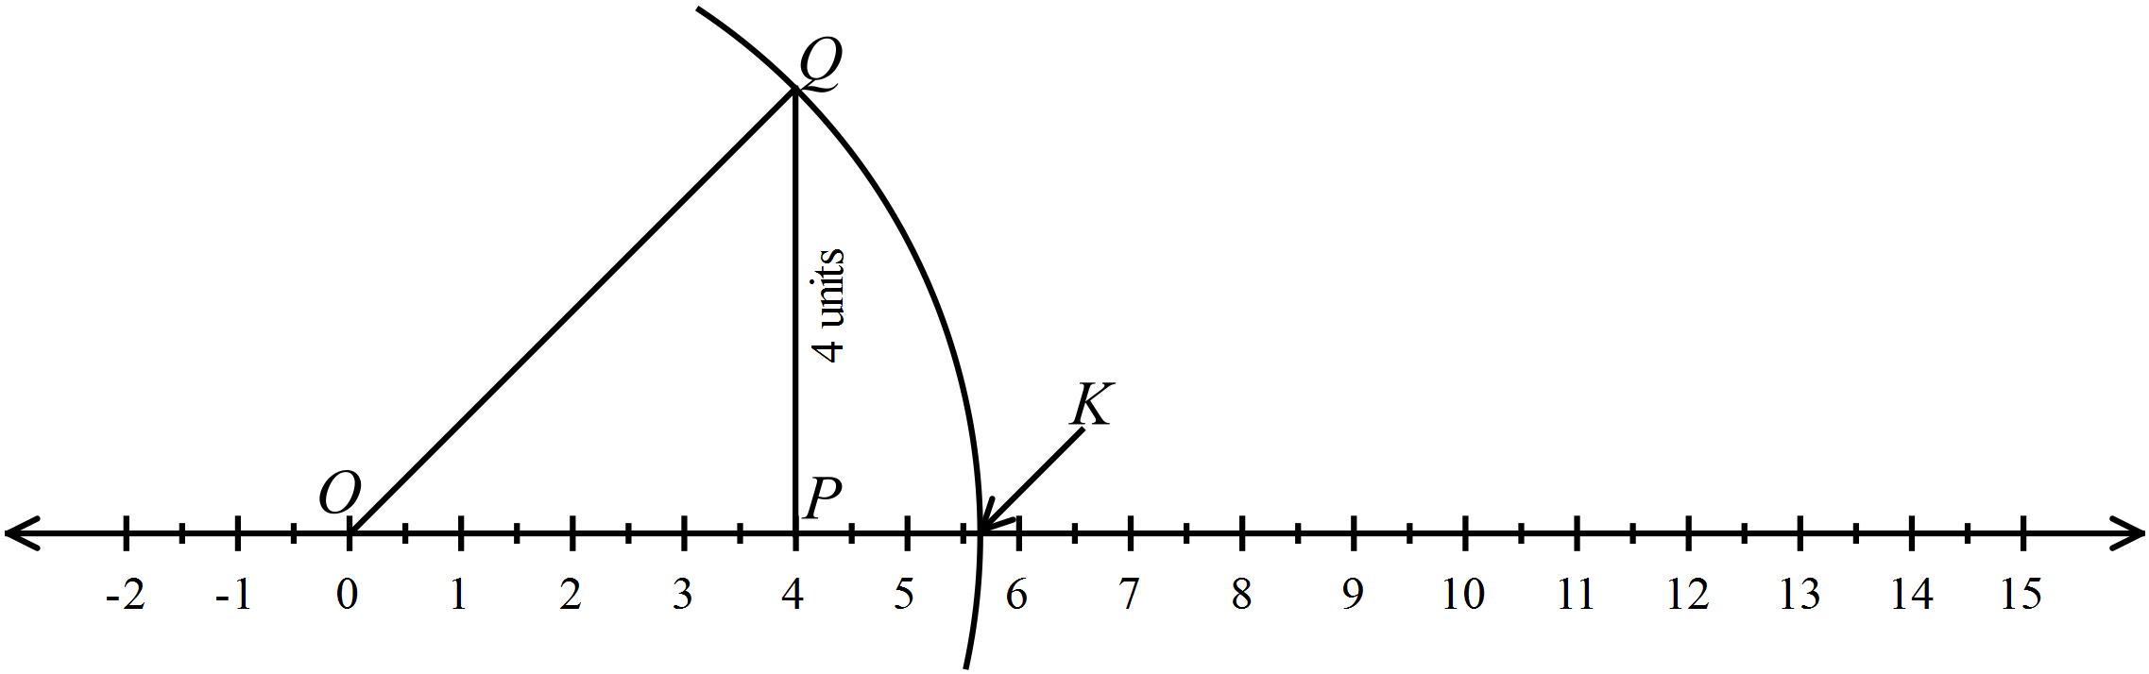

A. 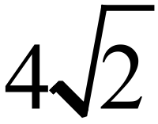 B. 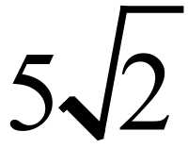 C. 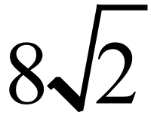 D. 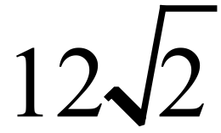

Year 9 | Surds | Calculator Allowed
Year 9 | Surds | Name___________________
Section 3 Longer Answer Section
Write all working and answers in the spaces provided on this test paper.

 |  | Marks
1. | - Express 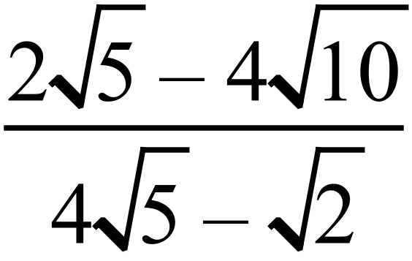 with a rational denominator.  ……………………………………………………………………………………………….  ……………………………………………………………………………………………….  ……………………………………………………………………………………………….  ………………………………………………………………………………………………. | 2
 | - Simplify the following, giving your answer as a single fraction in simplest form.  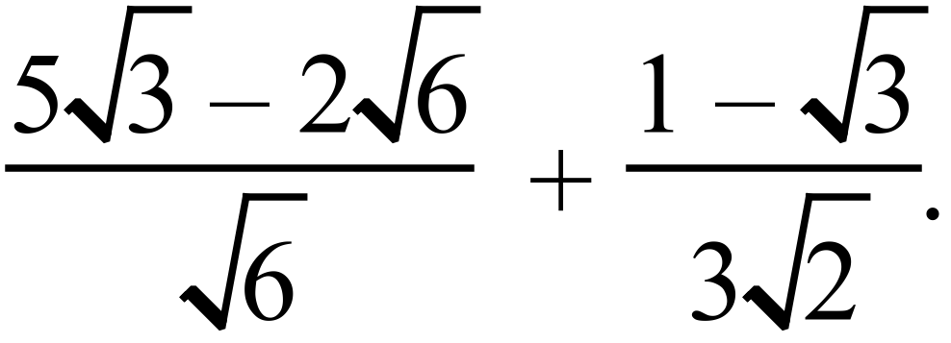  ……………………………………………………………………………………………….  ……………………………………………………………………………………………….  ……………………………………………………………………………………………….  ………………………………………………………………………………………………. | 3
 | - Express 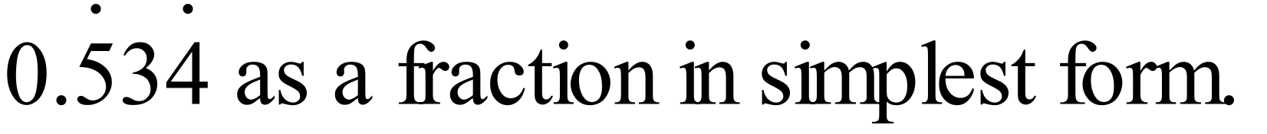  ……………………………………………………………………………………………….  ……………………………………………………………………………………………….  ………………………………………………………………………………………………... | 2

Multiple Choice Answer Sheet
Surds
Name _____________________________________________
Completely fill the response oval representing the most correct answer.

1. A B C D
2. A B C D
3. A B C D
4. A B C D
5. A B C D
6. A B C D
7. A B C D
8. A B C D
9. A B C D
10. A B C D
11. A B C D
12. A B C D
13. A B C D
14. A B C D
15. A B C D
Year 9 |  | Surds | Non Calculator
Section 1 Short Answer Section
ANSWERS
No. | WORKING |  | ANSWER
 | 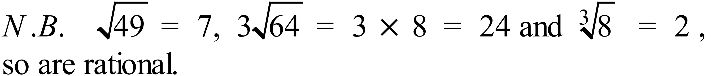 |  | Circle the surds marked at left
 | 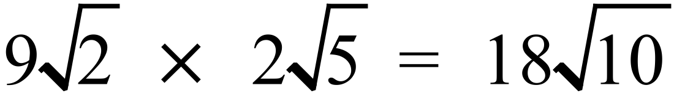 |  | 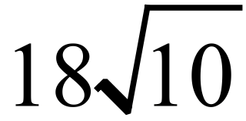
 | 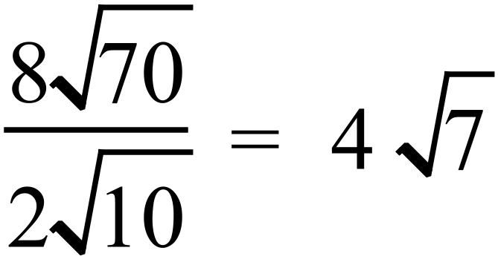 |  | 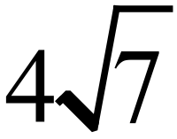
 | 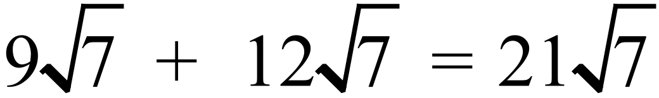 |  | 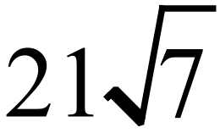
 |  |  | 54
 |  |  | 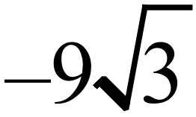
 | 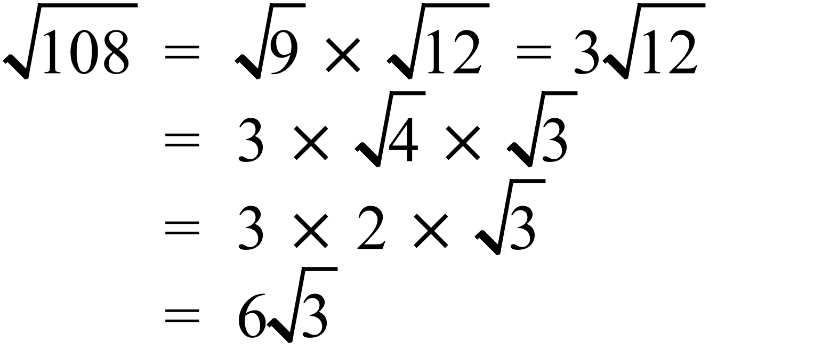 |  | 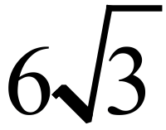
 | 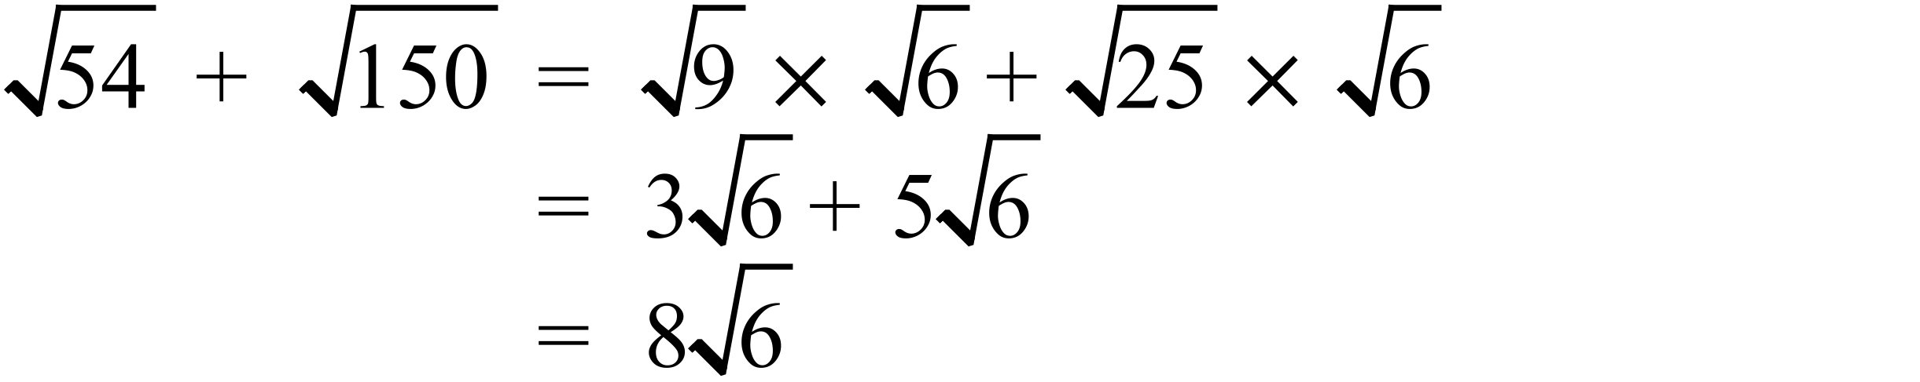 |  | 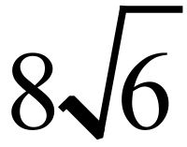
 |  |  | 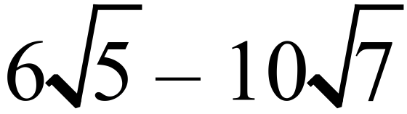
 | 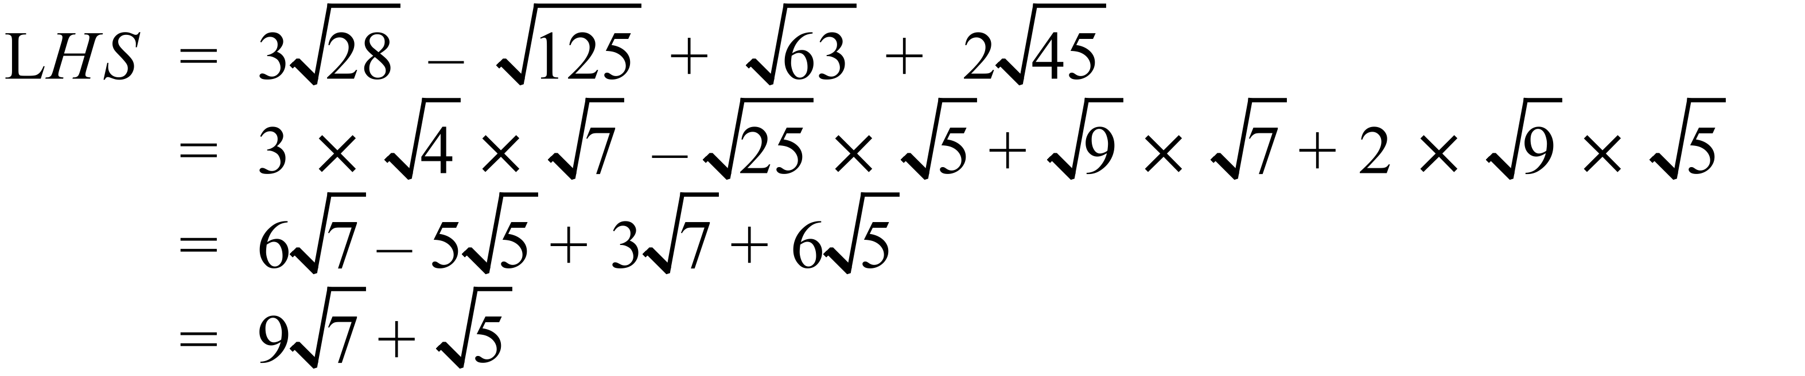 |  | 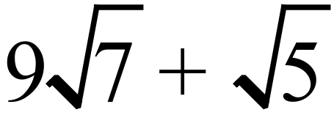
 | 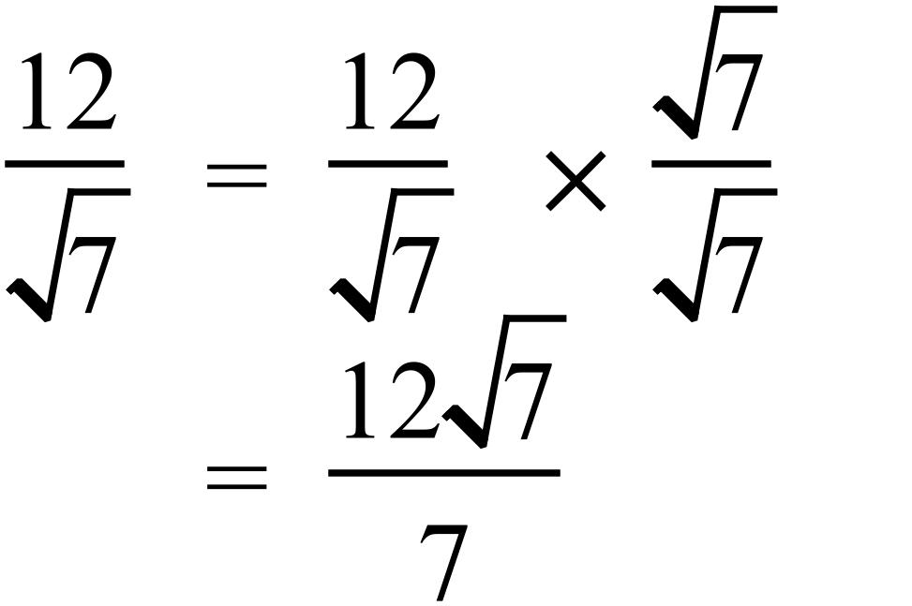 |  | 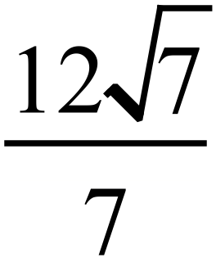
 | 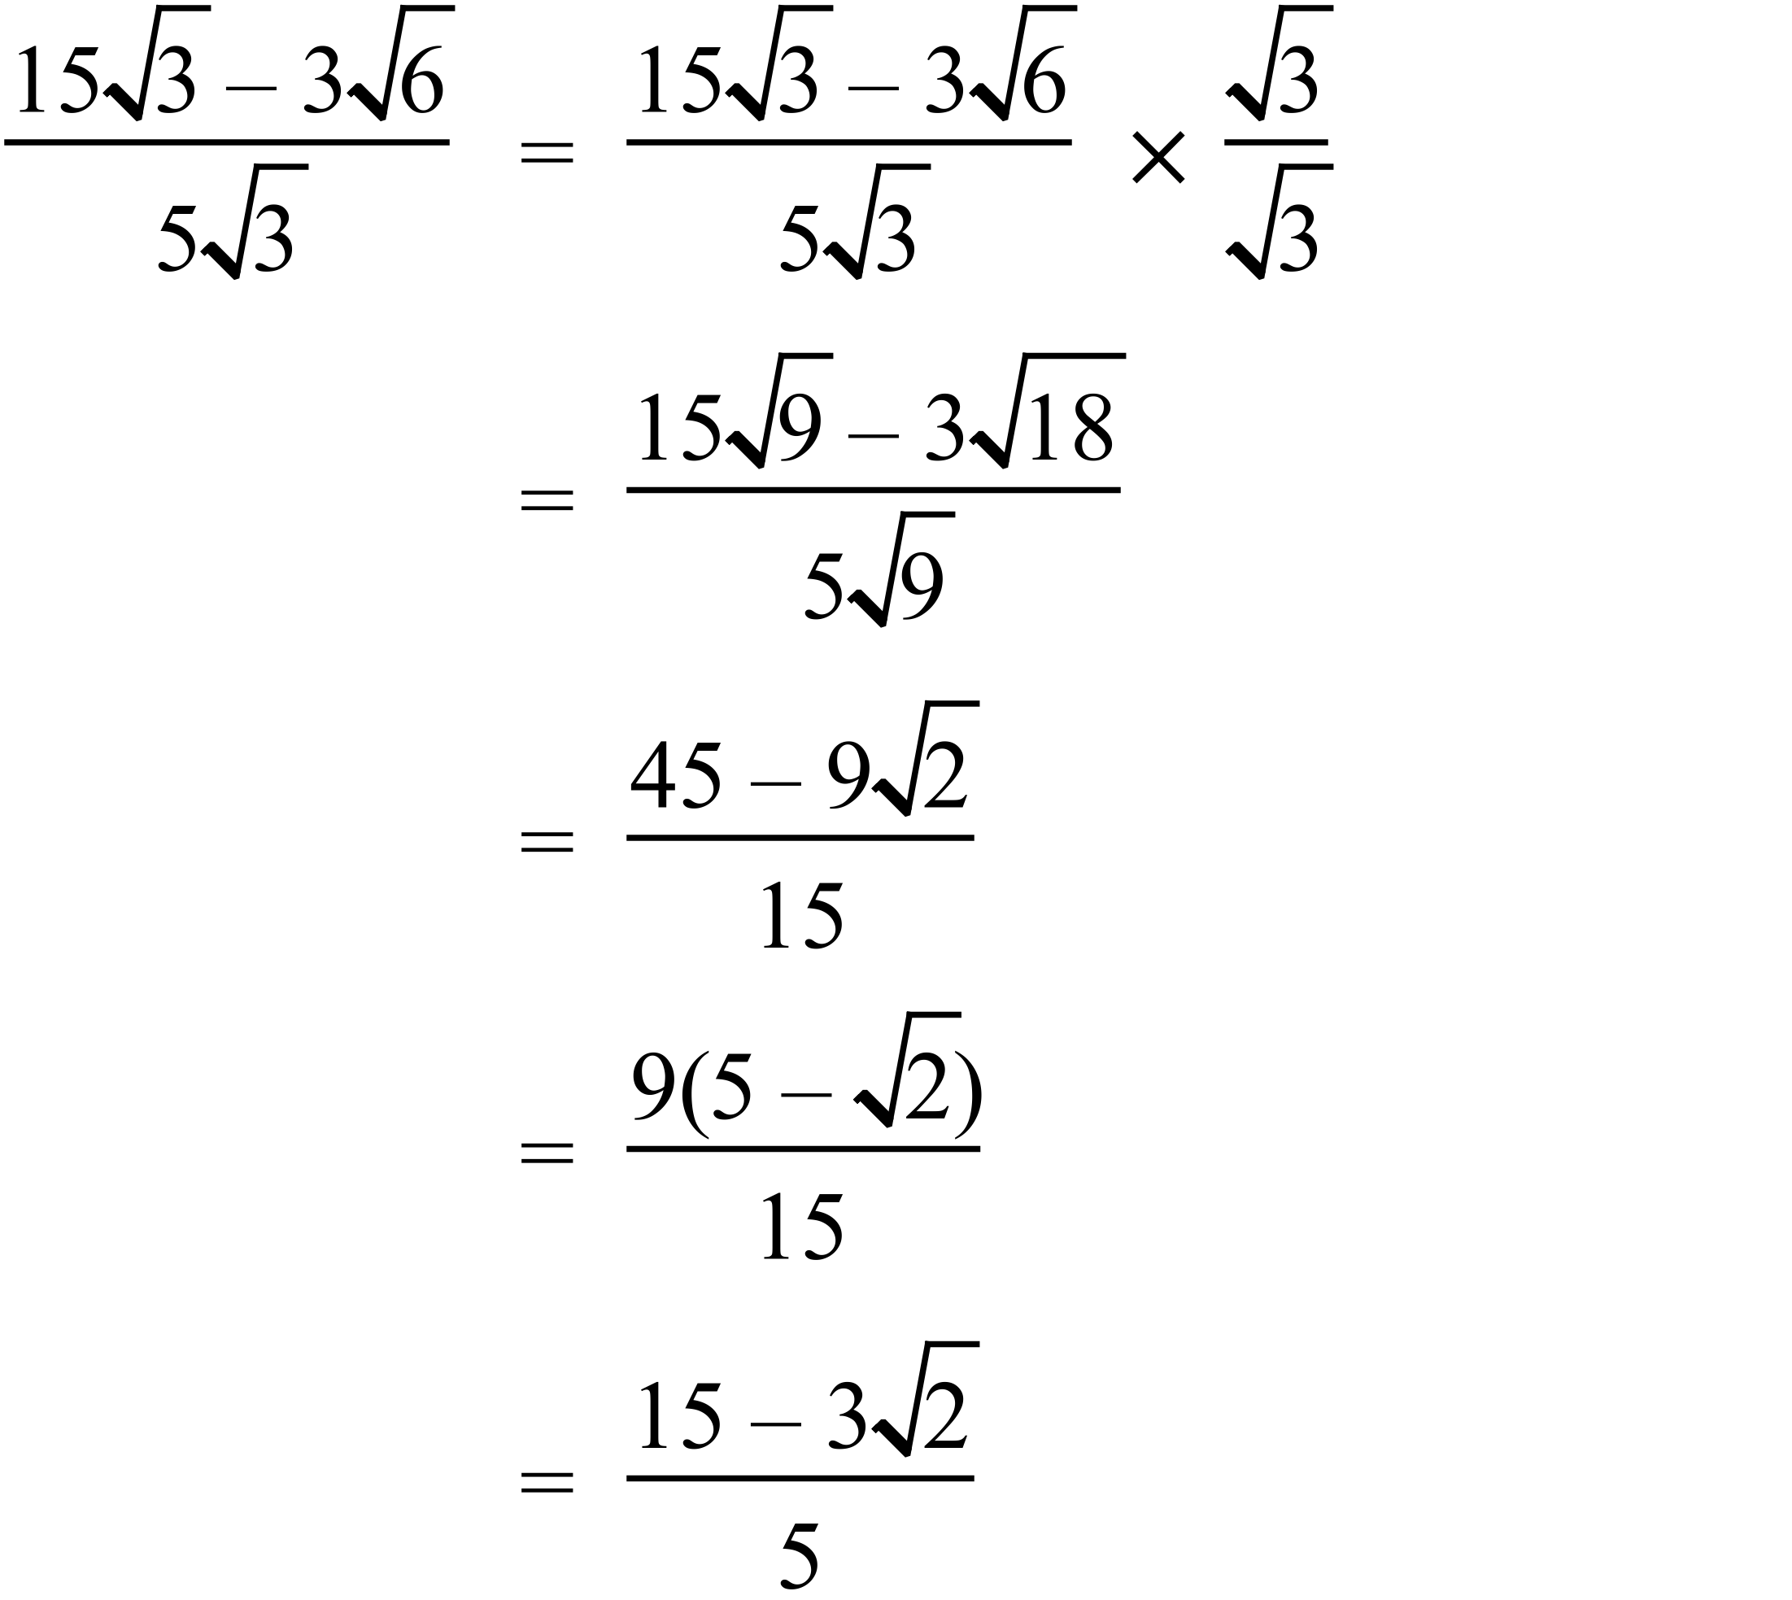 |  | 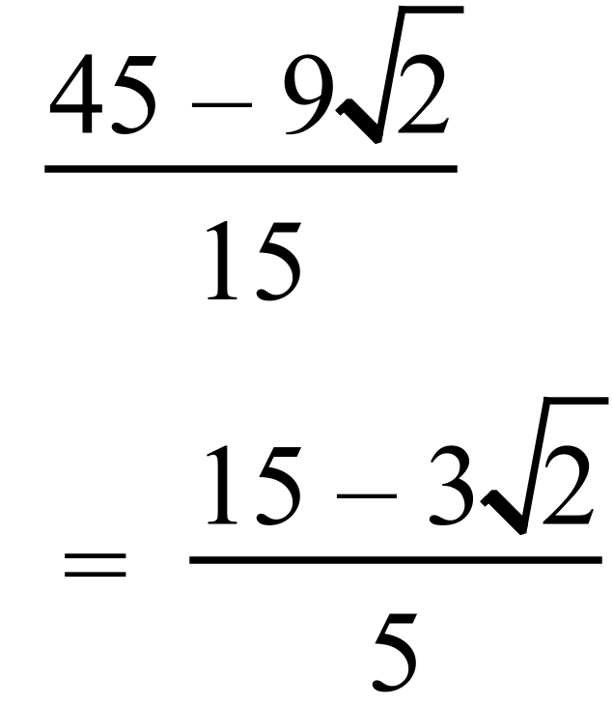  Either answer
 | 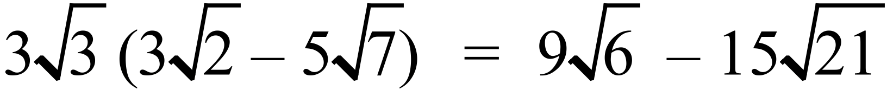 |  | 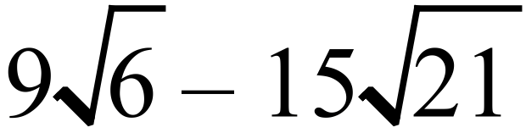
 | 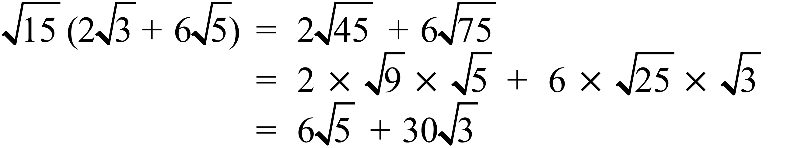 |  | 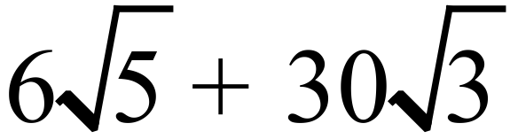
 | 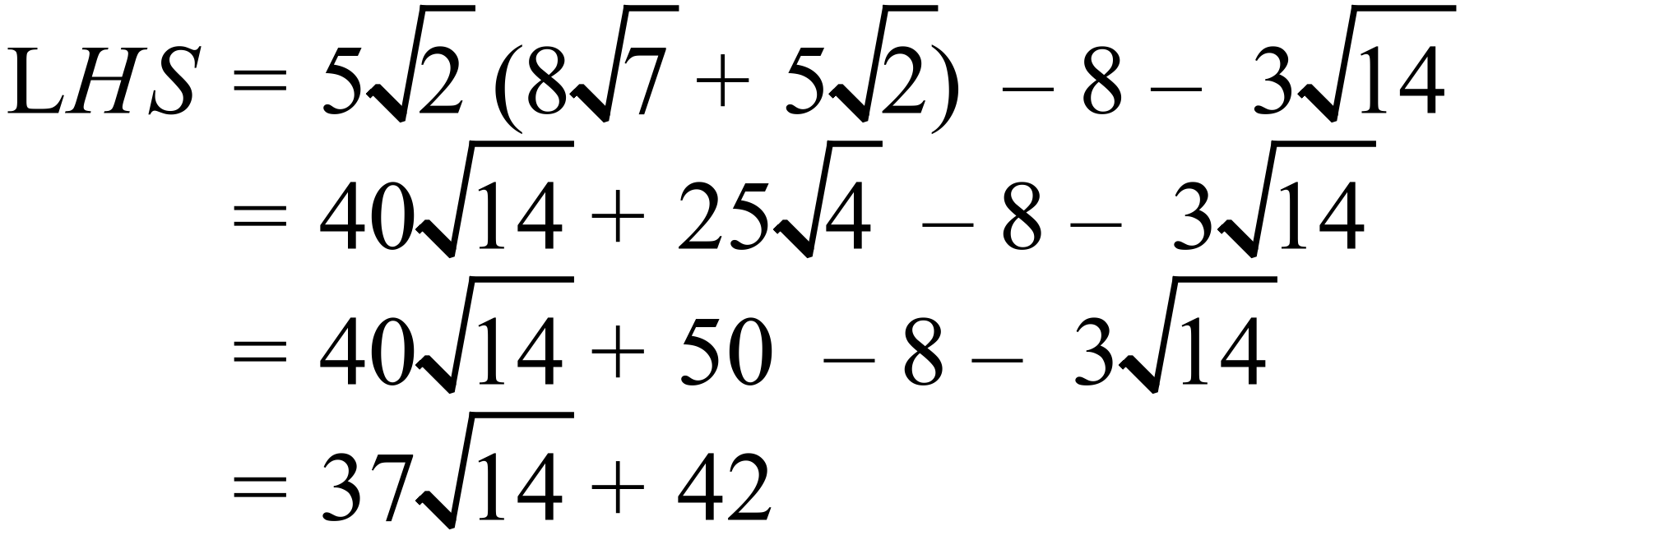 |  | 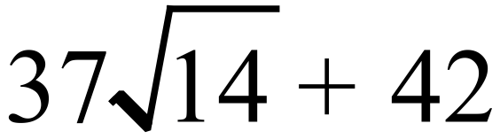
 | 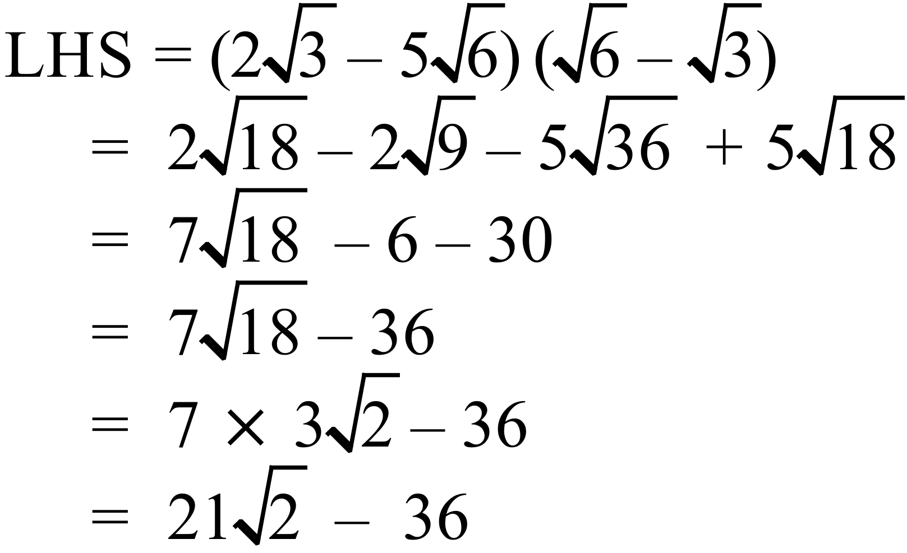 |  | 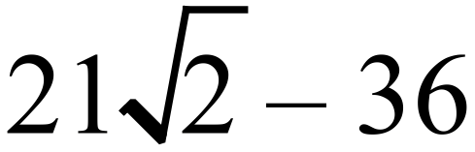
 | 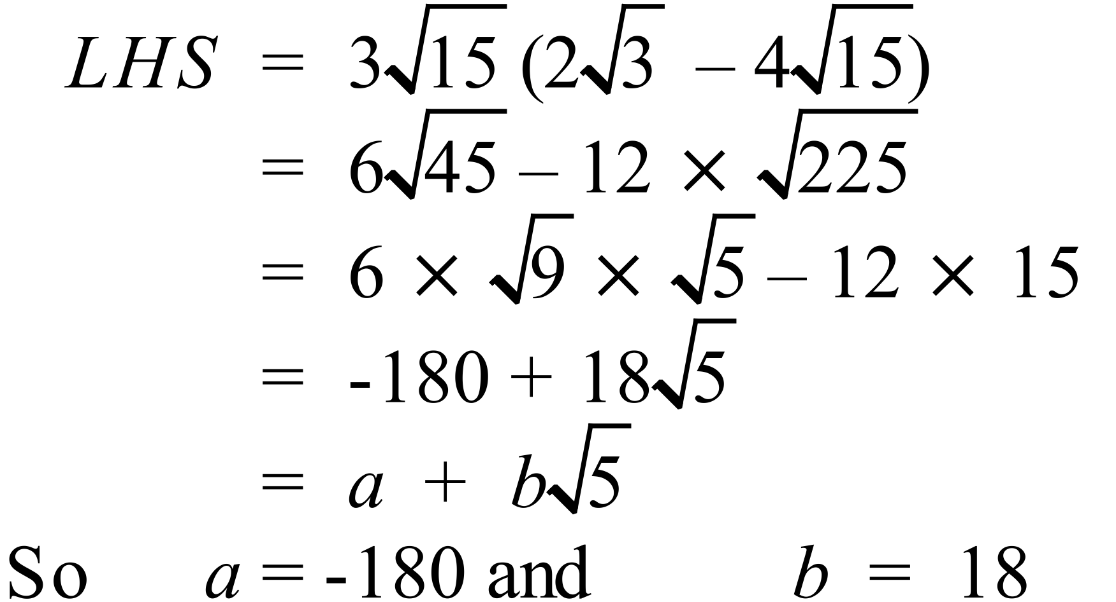 |  | 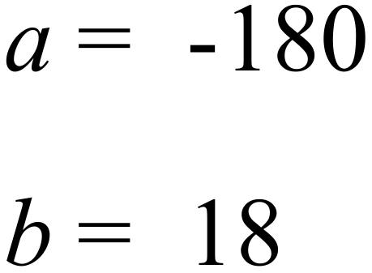
 | 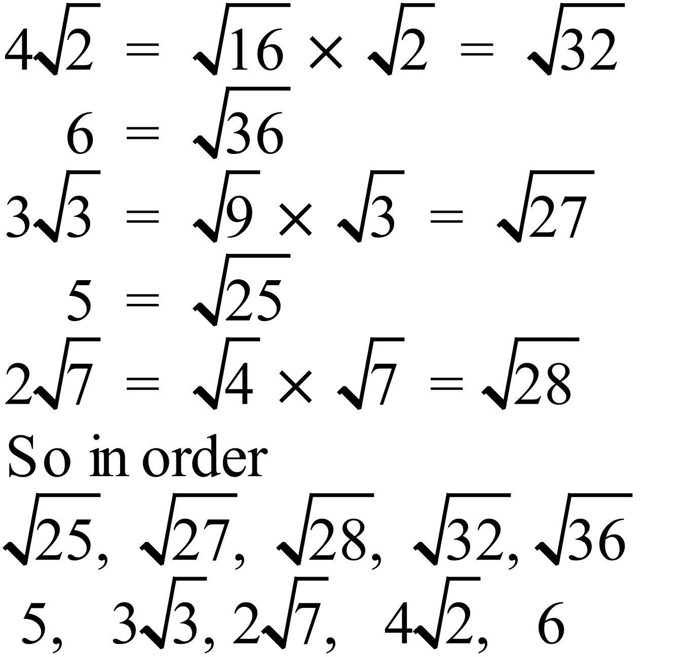 |  | 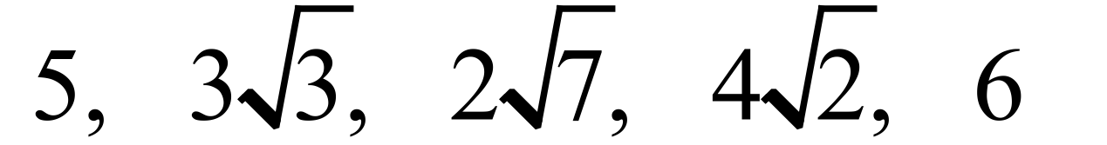

Year 9 |  | Surds | Calculator Allowed
Section 2 Multiple Choice Section
ANSWERS
No. | WORKING |  |  | ANSWER
 |  |  |  | C
 |  |  |  | D
 | 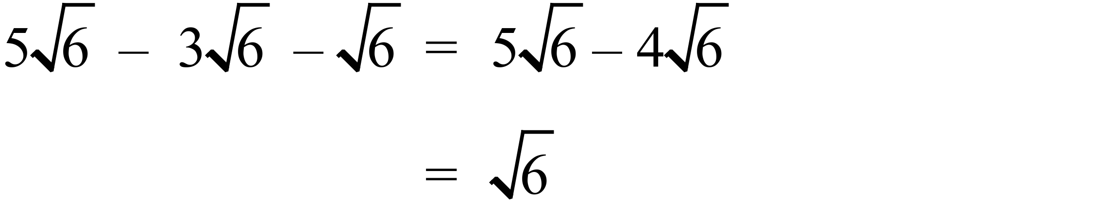 |  |  | C
 | 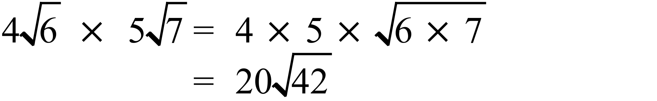 |  |  | D
 | 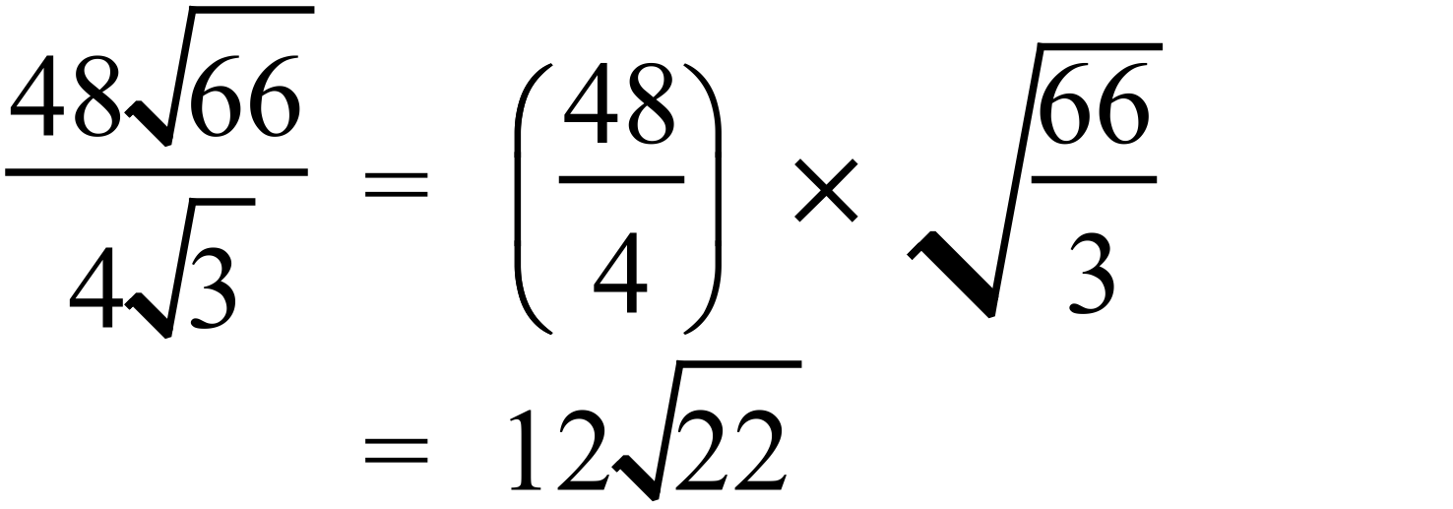 |  |  | A
 | 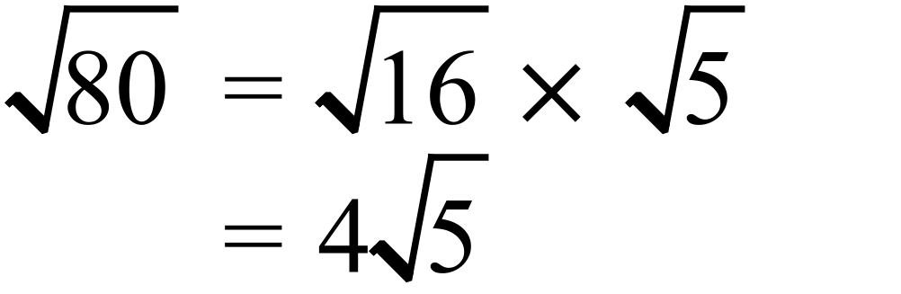 |  |  | B
 |  |  |  | B
 | 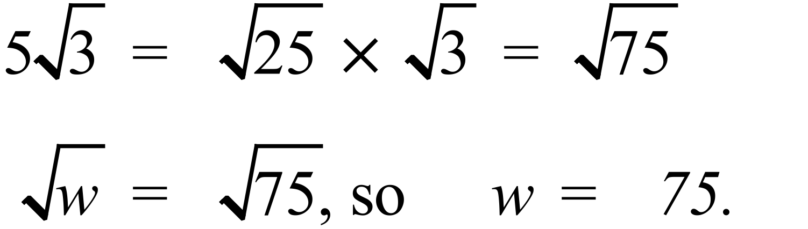 |  |  | D
 | 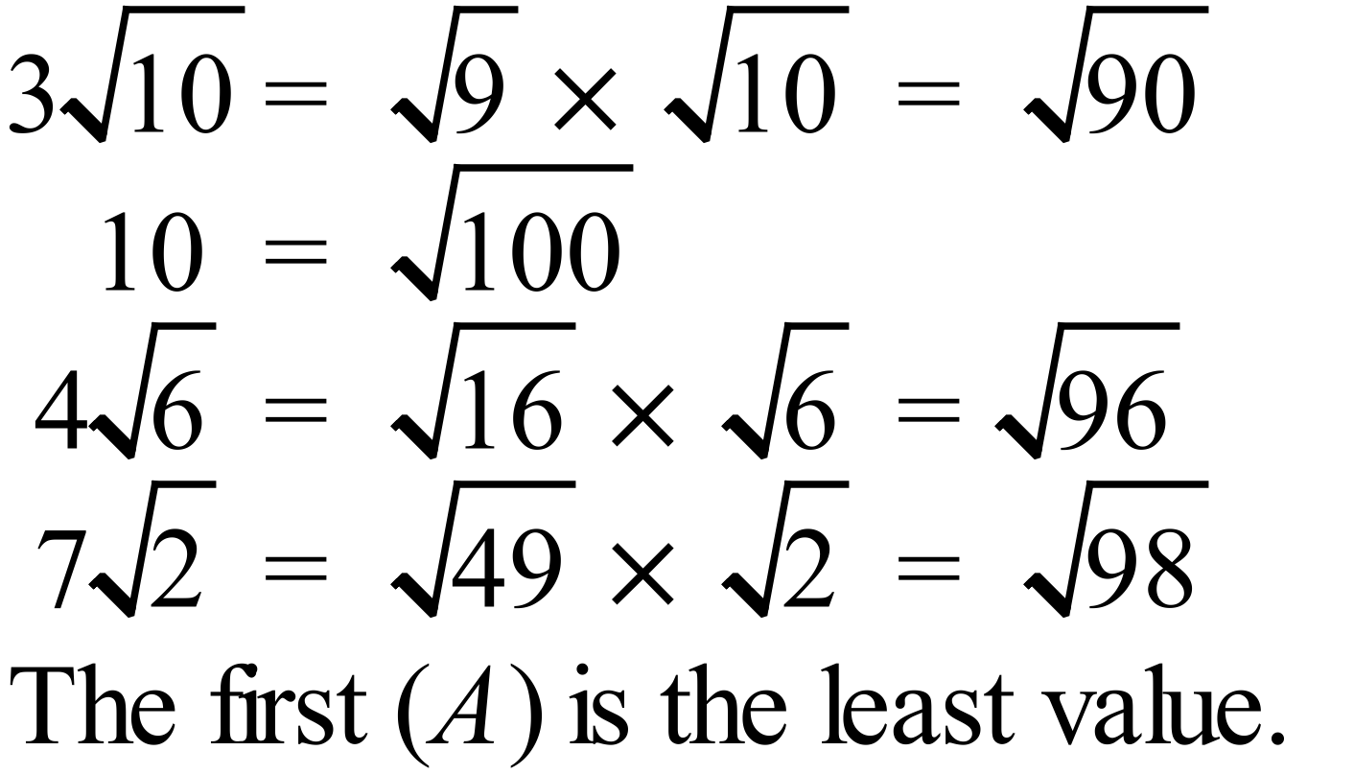 |  |  | A
 | 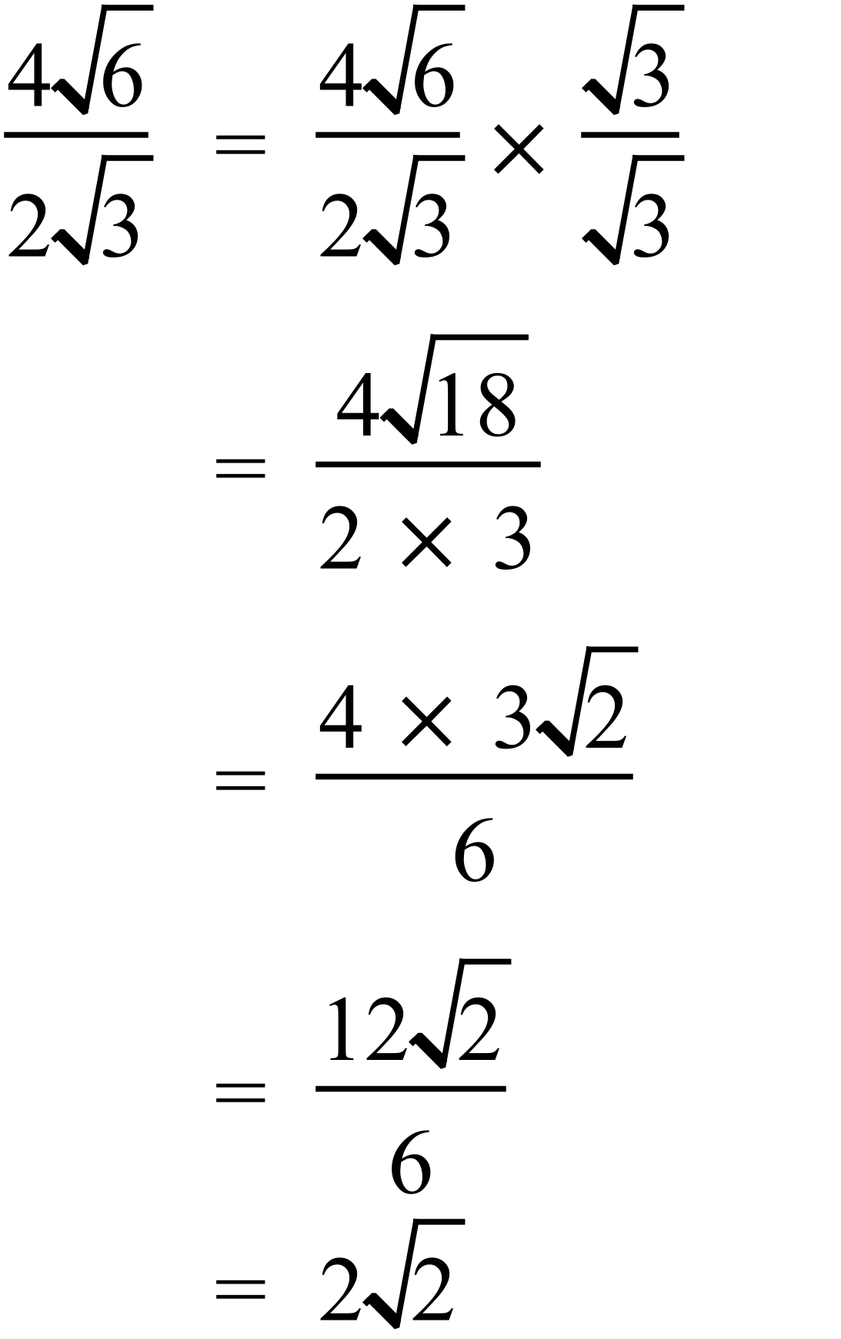 |  |  | B
 | 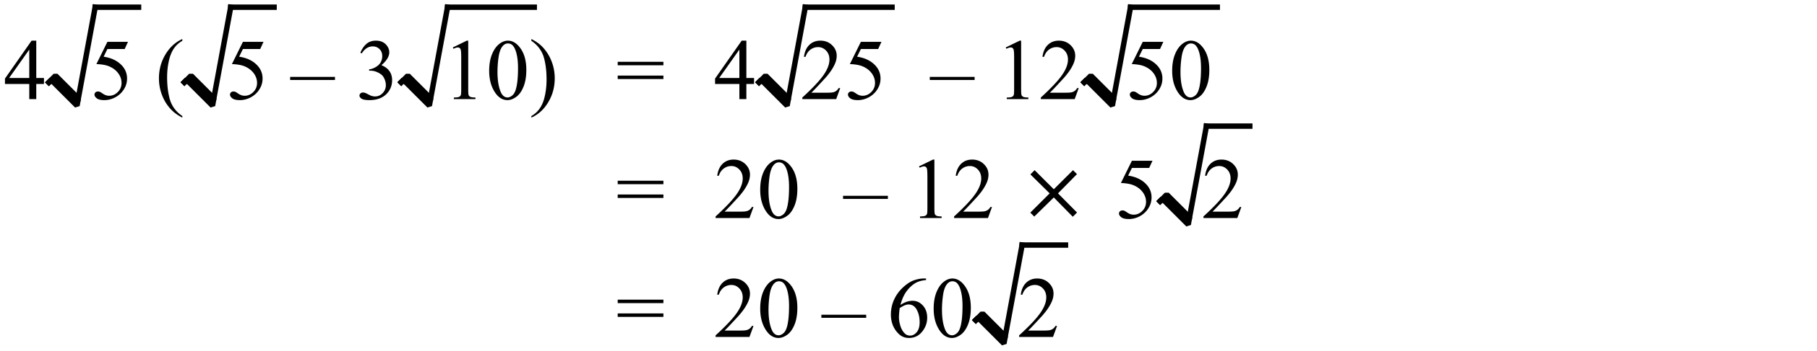 |  |  | D
 | 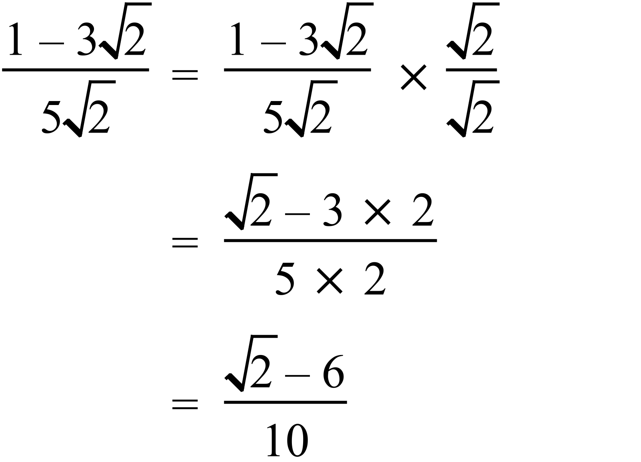 |  |  | B
 |  |  |  | C
 | 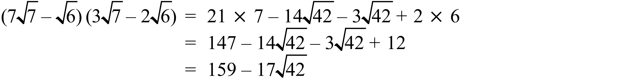 |  |  | C
 | 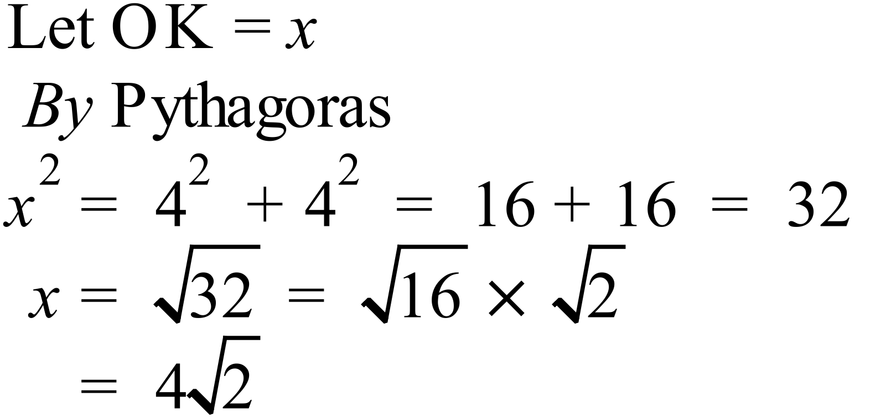 |  |  | A

Multiple Choice Answer Sheet
Surds
Name _______ANSWERS_______________________________
Completely fill the response oval representing the most correct answer.

1. A B C D
2. A B C D
3. A B C D
4. A B C D
5. A B C D
6. A B C D
7. A B C D
8. A B C D
9. A B C D
10. A B C D
11. A B C D
12. A B C D
13. A B C D
14. A B C D
15. A B C D
Year 9 |  | Surds | Calculator Allowed
Section 3 Longer Answer Section
ANSWERS
 |  |  |  | Marks
1. | (a) 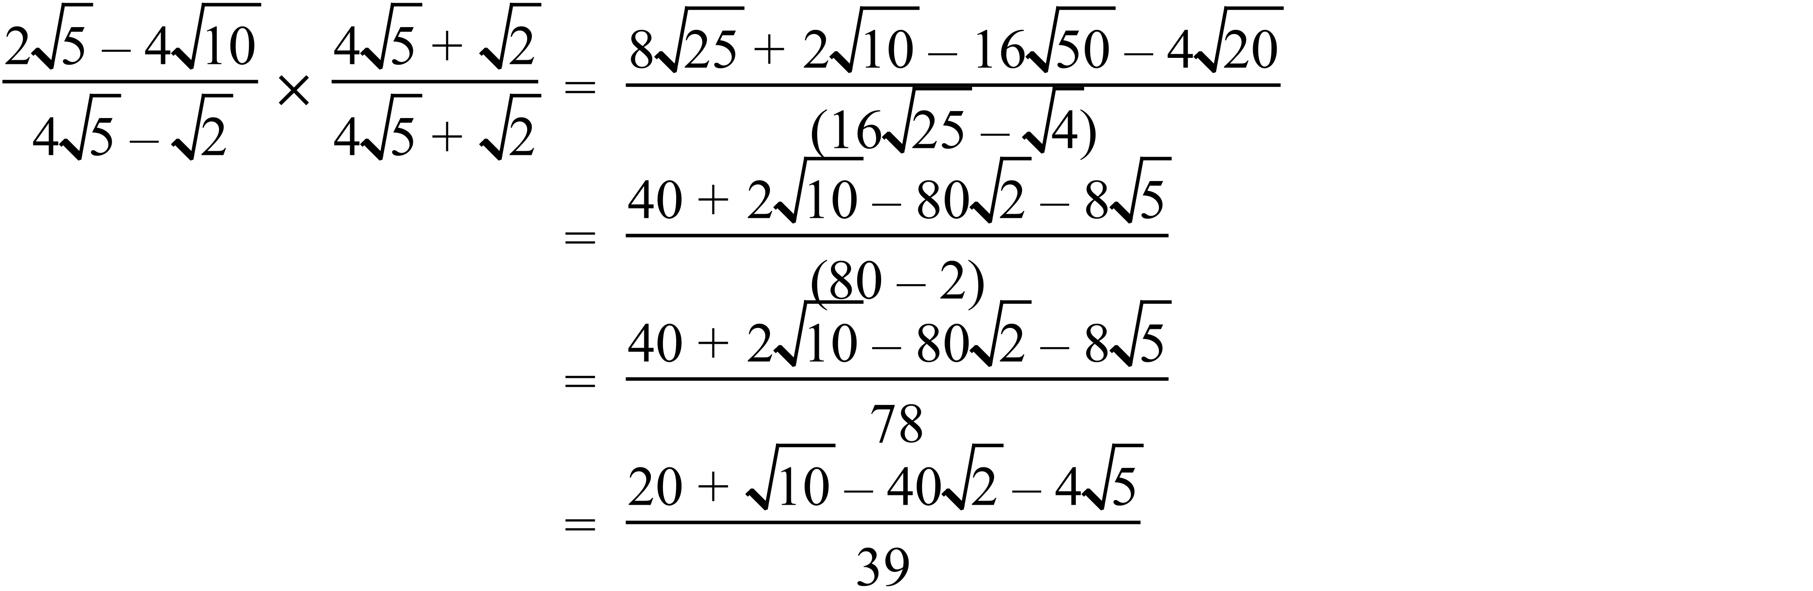 |  |  | 2 marks for correct simplified answer.  1 mark for a basically correct attempt which has only a minor error or two in algebra or calculation, or is incomplete but has a correct beginning
 | (b) 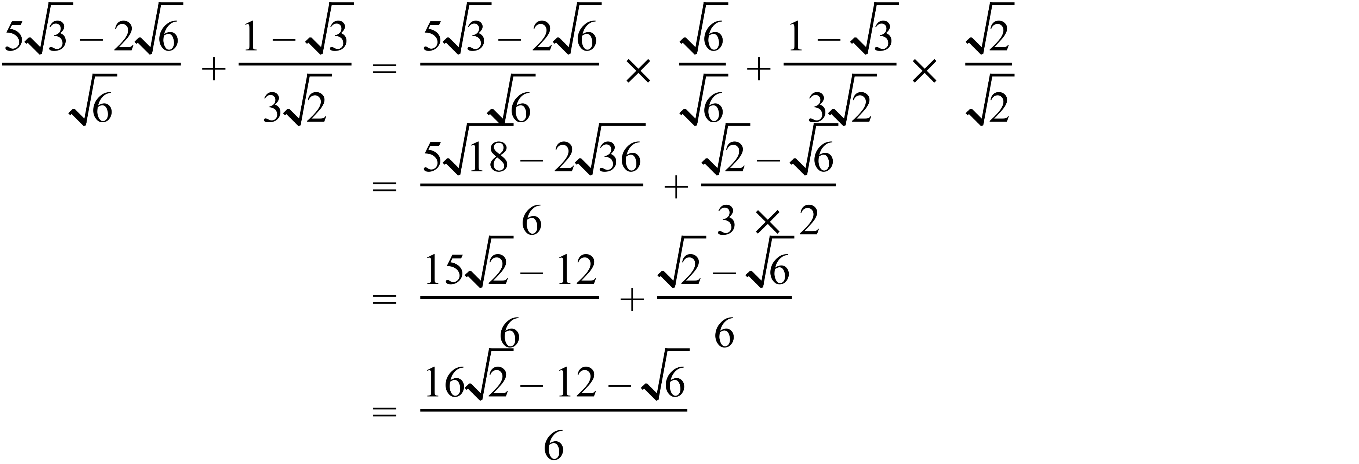 |  |  | 3 marks for correct simplified answer.  2 marks for a basically correct attempt which has only a minor error or two in algebra or calculation, or is incomplete but has a correct beginning  1 mark for an attempt with some correct working.
 | (c) 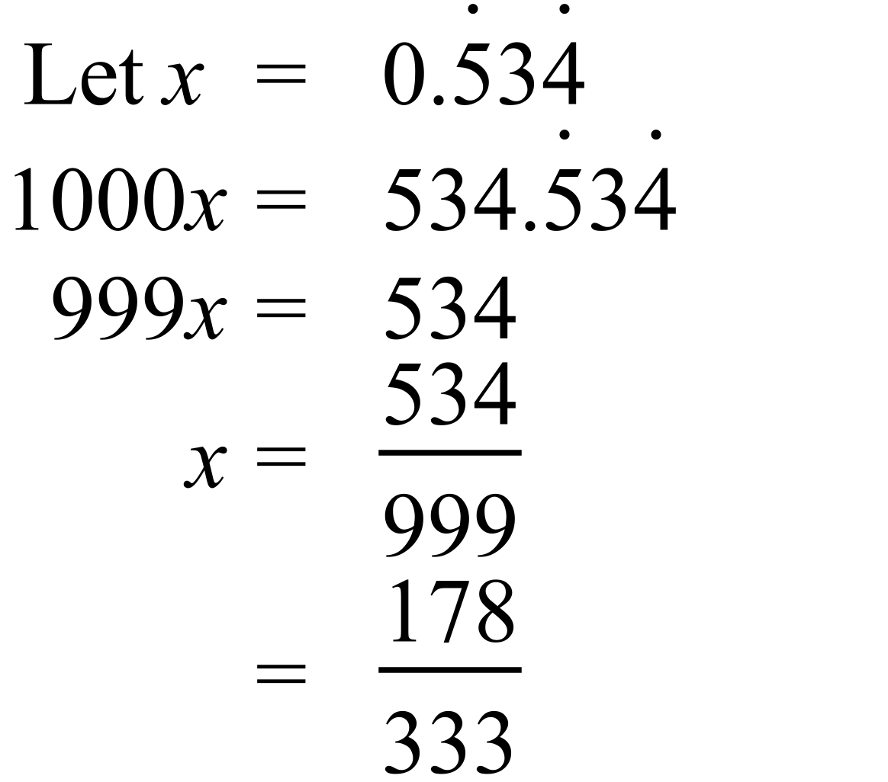 |  |  | 2 marks for correct simplified answer.  1 mark for a basically correct attempt which has only a minor error or two in algebra or calculation, or is incomplete but has a correct beginning

